What does Maths look like at our school?
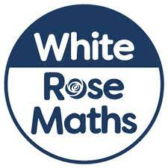
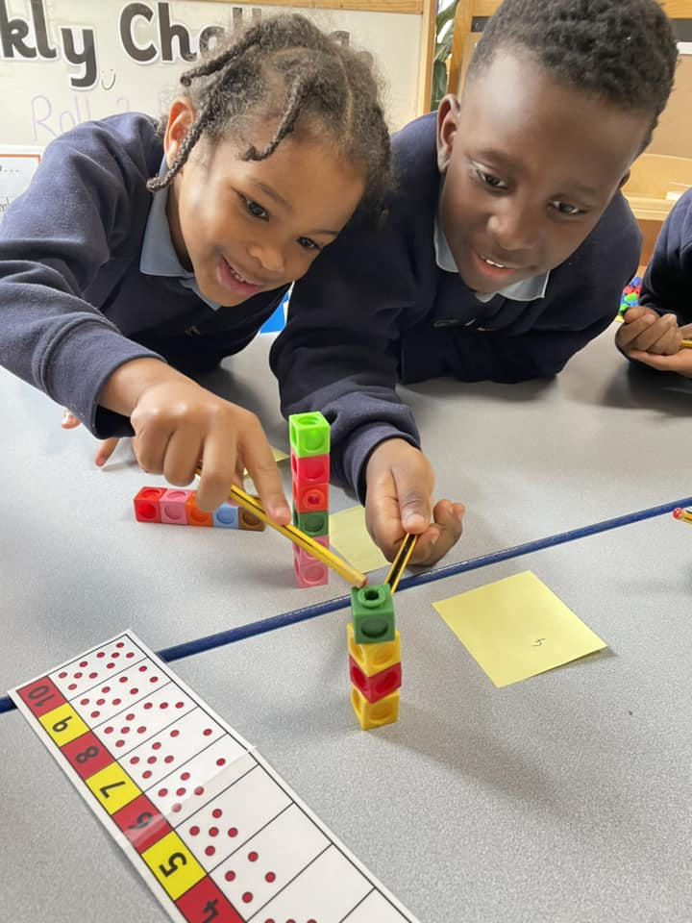
Our Mathematics curriculum has been designed to meet the statutory requirements of the 2014 National Curriculum; the programmes of study being the basis for learning and adapted to meet the needs of our pupils and to reflect the diverse area in which they live. We also regularly refine the curriculum in line with the latest guidance, subject research reports from Ofsted and current affairs.
The National Curriculum sets out what pupils need to learn which we cover through The White Rose scheme that we have adopted after being approved by the DfE. The schemes have been designed to allow good coverage of the age-related expectations for the mathematics curriculum as well as providing continuity and progression throughout each year group. The schemes have been adapted to allow teachers more flexibility with their planning so that they can address any gaps in pupils’ knowledge.

Our main aim is to make our children fluent in solving calculations involving the four mathematical operations and to equip them with the tools to solve a variety of problems. The programmes of study are, by necessity, organised into distinct areas, but pupils will make rich connections across different mathematical strands. Mathematical skills are developed across the curriculum in subjects such as Science, Design and Technology, Computing and PE. To facilitate children to know more and remember more, key concepts run through the whole of our curriculum and opportunities to revisit previous learning are planned into every lesson.

Our Key Principles:
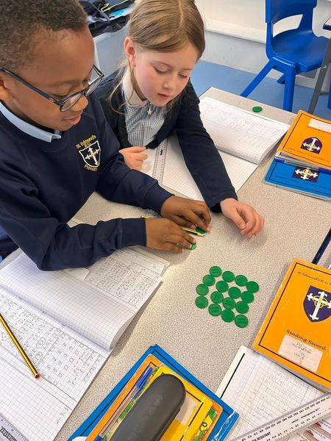
- We believe maths is a subject that all children can do
- We believe that maths should be fun, engaging and rewarding for all learners
- We embed fluency, reasoning and problem solving at the heart of our maths curriculum
- We strive for all children to become competent mathematical thinkers, confident in making connections
- We support children in their understanding through a variety of representations, including concrete, pictorial and abstract

What does a Mathematics lesson look like in our school?
Developing problem solving, reasoning skills and mathematical vocabulary is a thread that runs through all of our Maths lessons. Pupils are constantly challenged to explain why, to prove how they know, to convince that they are correct or to find all possible outcomes. They have the opportunity to use a wide range of resources to support their learning such as hundred squares, number lines, Numicon, cubes, place value cards and other small apparatus.

EYFS
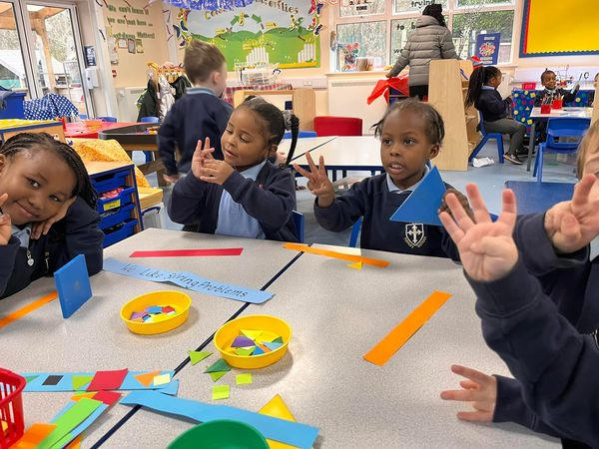
In the Early Years Foundation Stage, our curriculum is taken from the statutory framework. At our school we ensure that all areas of EYFS learning are important and interconnected using planned, purposeful play and a mix of adult-led and child-initiated activities.
Mathematics is taught and reinforced within all areas of the curriculum; the children explore mathematics through different contexts, including storybooks, puzzles, songs, rhymes, puppet play, and games.
To help prepare the children for Year 1, Reception teachers plan lessons using the ‘White Rose’ curriculum. This provides children with opportunities to develop and improve their skills in counting, understanding and using numbers, calculating simple addition and subtraction problems. As well as number, the curriculum supports the children with seeking patterns, making connections, recognising relationships, working shapes and measures, and counting, sorting and matching. Children use their knowledge and skills in these areas to solve problems to ask new questions and make connections across other areas of their learning. It is fantastic to see our children learning through play!

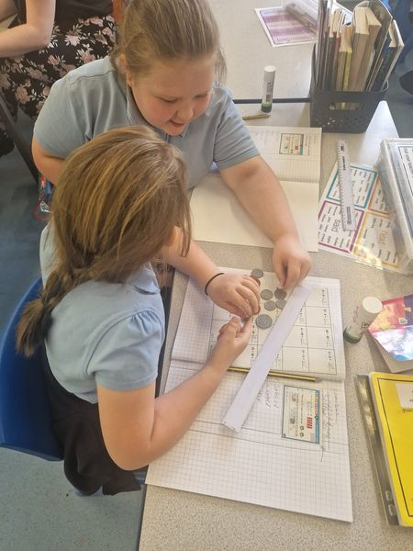
KS1 and KS2 - Each lesson begins with a ‘Flashback 4’ activity in order to recap on previous learning. Starting lessons like this really supports the children to know more and remember more of the mathematical concepts that they are expected to learn for their specific age group. Within the main teaching of a lesson, the CPA (concrete, pictorial, abstract) model permeates throughout Years 1-6. The links made in maths lessons are explicit and focus on real world examples, visual representation, language and manipulatives coming together to solve problems in context. Giving the children time to practice their fluency of mathematical skills and applying them to problem solving and reasoning challenges during a daily lesson develops deeper understanding and gives the children the tools they need to become competent and confident mathematicians over time.

In all mathematics lessons, this is what you might typically see:
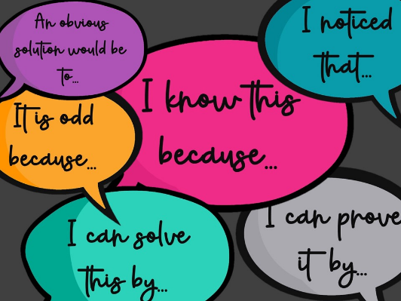
• Happy and engaged learners
• Self-motivated children
• Open ended investigations - low threshold/high ceiling tasks
• Word problems
• Different representations of calculations
• Paired/group work – lots of collaboration
• A range of different activities including practical and use of ICT
• Engagement and perseverance
• Children challenging themselves
• Children talking about, sharing and reflecting on their learning?

How can I support my child’s learning in Mathematics?
As soon as your child starts school you can help your child with maths using everyday items found in the home. Examples include; building things with bricks as this is a good way of developing maths skills through solving problems, talk about times of the day, spot patterns and shapes in the house, practise forming numbers and count everything!


In order to consolidate learning, pupils in KS1 + KS2 are given a weekly homework task that links to the learning that is currently taking place in their maths lessons. Study books are also provided to support the pupils (and parents) with revision of strategies taught. School subscribes to a few online resources that are free for your child to use. Each pupil has access to ‘Numbots’ and ‘Times Tables Rock Stars’ in order to practice their rapid recall of the 4 rules of number. Teachers also regularly assign work on ‘Mathletics’ that is aligned to the learning that is taking place in school and each pupil has access to this digital platform too. If any parent faces a barrier to accessing the digital platforms that the school is subscribed to, make an appointment to speak to Mr Usher who will endeavour to find a solution with you.


There are loads of other things that you can do to get your child to think and talk mathematically as they get older. As much as possible, we want them to use any mathematical vocabulary they learn in class. A few examples of this could be; ask your child if they can help you find the best deal for your car insurance, work out which supermarket deal is cheapest when out shopping, work out differences in time for when a TV programme starts. Everyday tasks like these help your child to recognise and understand maths in real life and solve problems in the world around them - giving maths a sense of purpose.

Reading
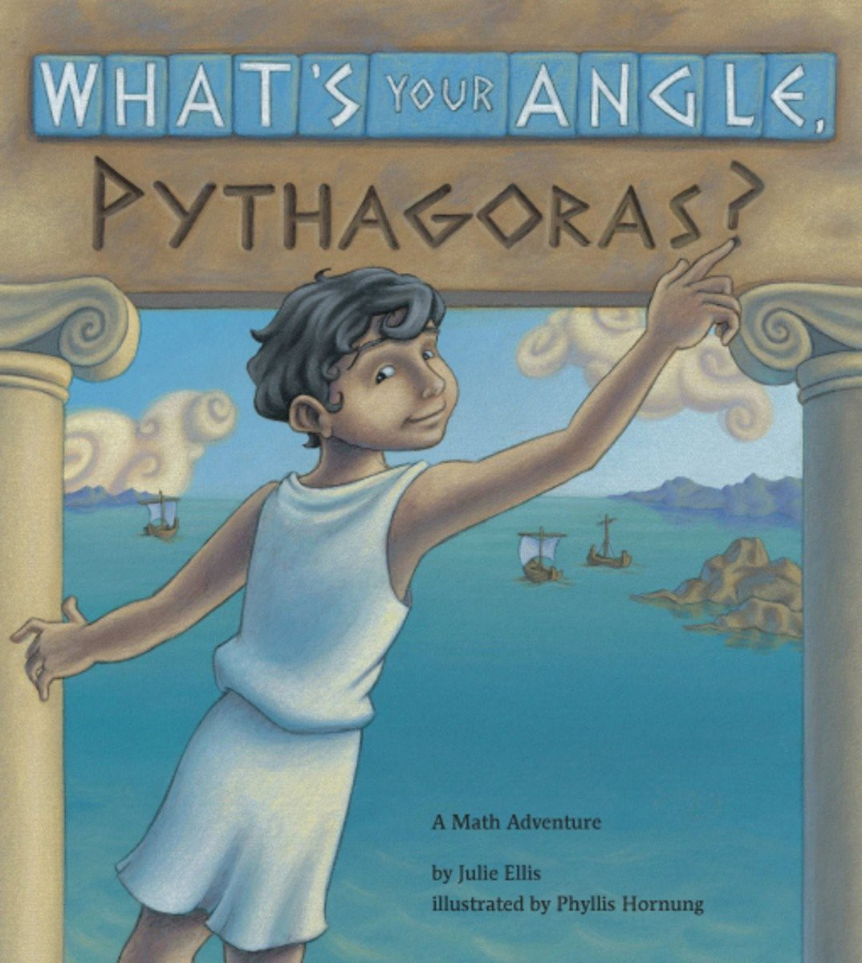
What has maths got to do with reading? Well, if your child is struggling to read, they aren’t going to be able to access the curriculum. Lots of the questions and problems children have to solve in maths are written down and the children need to be able to read them. We have a saying in our school, ‘we learn to read so we can read to learn.’ So, please support your child with all of their learning by hearing them read each night. We have plenty of books in our classrooms and library which support our maths curriculum as well as inspiring your child to enjoy and achieve in maths.

Assessment

Assessment has to serve a purpose and teachers are continually assessing your child in all types of ways so they can help them progress with their learning. In every maths lesson, teachers are questioning and discussing with pupils to find out what they do or do not know so that they can give them the right support. We have weekly arithmetic tests that help the children to solve maths calculations in their heads or with the help of jottings. Every 2 or 3 weeks, all pupils in KS1 complete an ‘end of unit check’. This informs the teacher about how well each pupil has retained the knowledge and skills taught. All KS2 classes complete a mini assessment before each unit, to help the teachers understand what knowledge the children have remembered from previous year groups and this helps them to plan lessons accordingly. All pupils complete a more in-depth summative assessment 3 times a year. A group report provides the teacher with a diagnostic analysis to support them with future planning and implementation of any necessary interventions. This data is kept on record to track your child’s progress as they learn through the year. The tests also show the children what fantastic progress they have made and what they need to learn next. Assessment results are shared with parents at the mid-way point through the year and at the end of the year so you can see how well your child is doing.

Who do I speak to if I want to know more about what my child is learning in maths at school?
Your child’s class teacher knows your child best and is best placed to keep you informed about the content of maths lessons. Miss Loughrey is our Mathematics Subject Leader and she will also be only too happy to answer any questions. queries or concerns that you may have about all things maths!

Extra Support
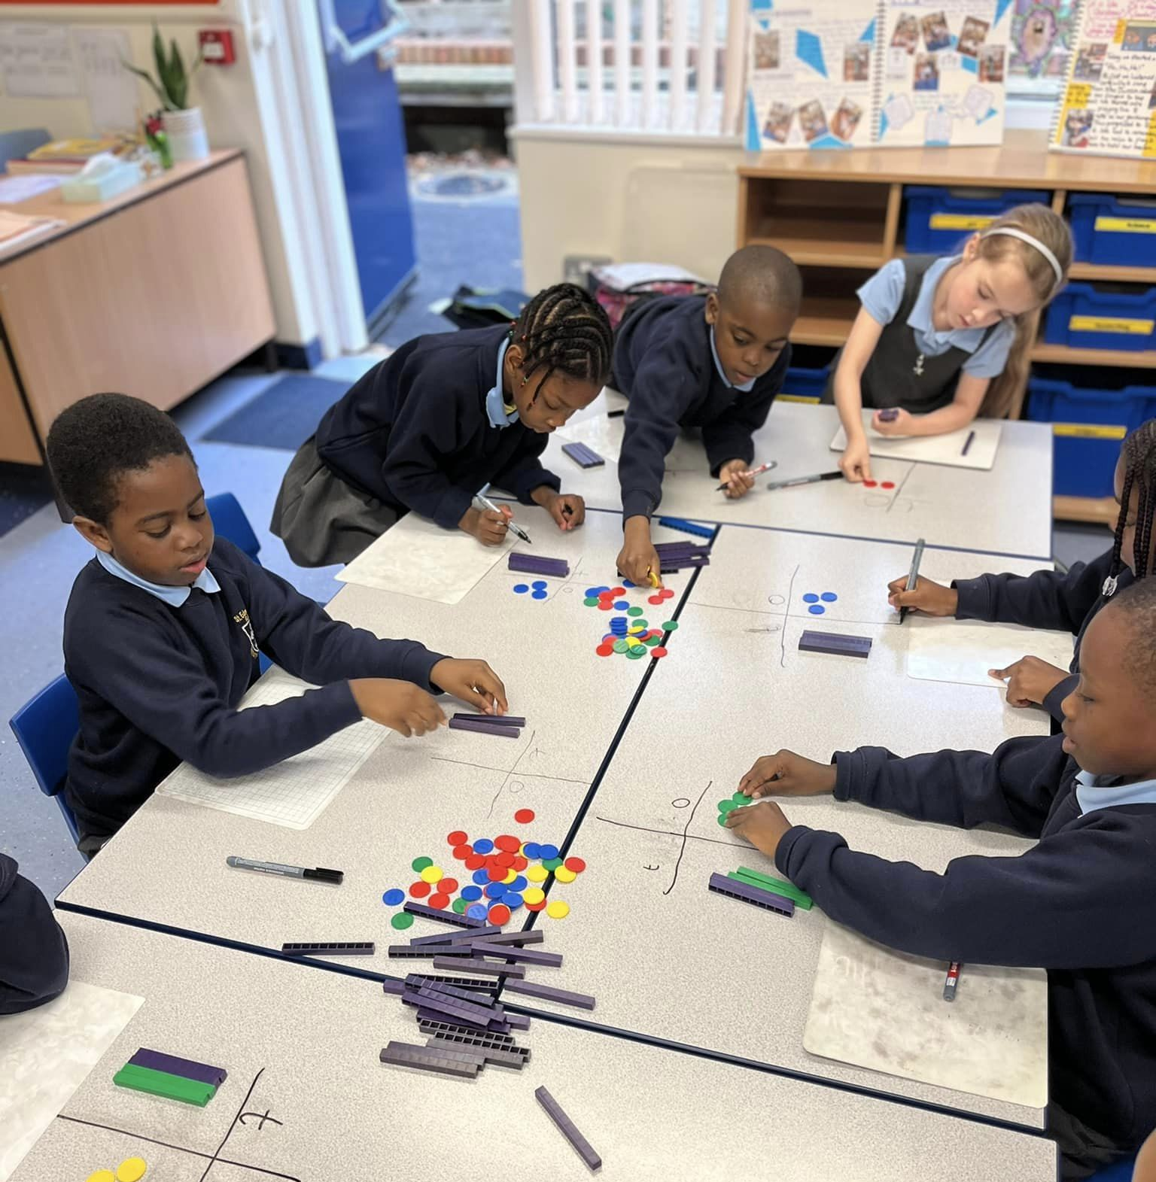
During their time at school, some children may need extra support in various areas of the mathematics curriculum, this is because children learn at different paces and have different learning styles. It isn’t anything to worry about and it is good that we can provide them with extra help when needed. At our school, we use our teaching assistants in class to provide extra support to the children who need it. They also do some extra intervention work as well and this is really targeted at certain mathematical concepts that are essential for a child to make progress in maths. This can be on a 1:1 with a child or within a small group. If you think that your child would benefit from some extra support in maths, please speak to your child’s class teacher or make an appointment to speak to our SENDCo, Mrs Shaw.
Safeguarding and well-being

A child’s welfare, well-being and safety is of the utmost importance to us. A child can’t learn or make any progress in school if they don’t feel safe and secure. We all know they need to be happy and we are here to ensure all of our children are nurtured to reach their full potential. Sometimes, a child just isn’t ready to access learning because of other problems. We have a special programme in school to help any children who may be struggling with their emotions and well-being. If you have any concerns about your child or in fact another child, please do not hesitate to contact one of our Designated Safeguarding Leads, who will be happy to talk through any concerns you may have.

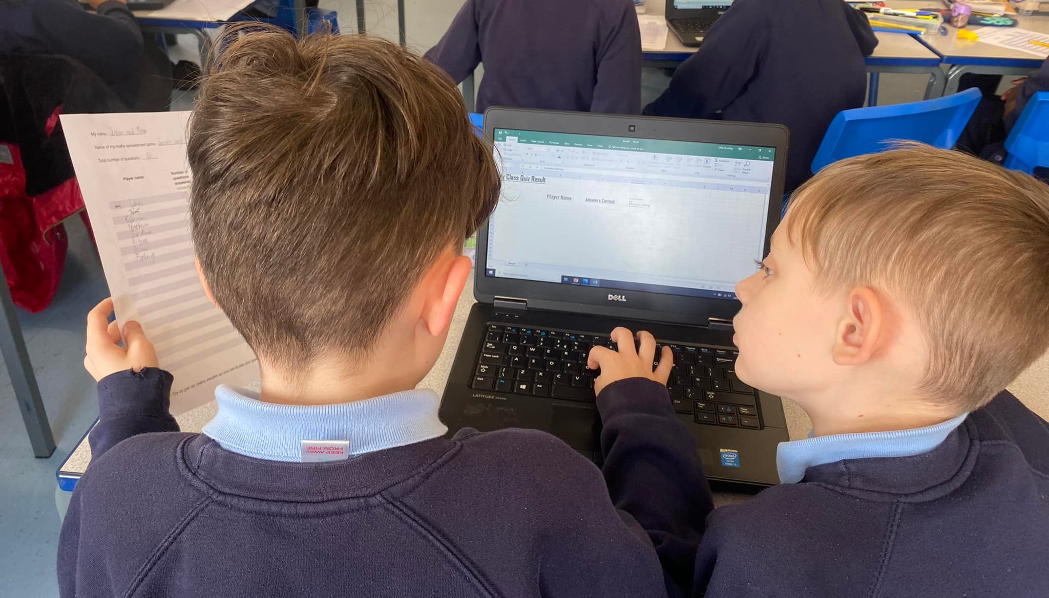
Personal Development
Due to its breadth and balance by design, the Mathematics curriculum in KS1 +KS2 provides many opportunities for mathematical discussion through reasoning and problem solving and this allows the pupils to make useful connections between mathematical concepts and practical problems that they are likely to encounter in adult life. The Maths curriculum is linked to other curriculum subjects such as Science, Geography, Computing, P.E and Design Technology and teachers exploit every opportunity both inside the classroom and beyond in order to link the Maths curriculum to these other subjects. They aim to provide opportunities for the children to demonstrate that they have a mastery of certain mathematical concepts.

