What does Music look like at our school?
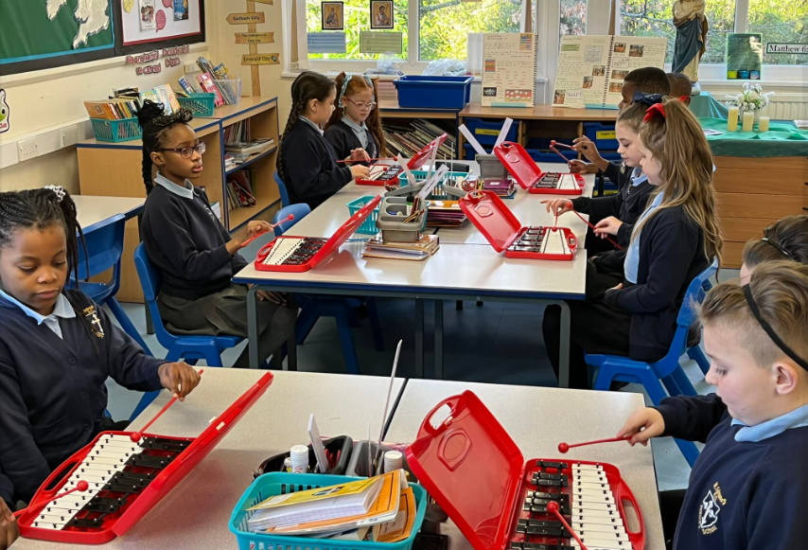
Right from when your child enters into our Nursery and all the way through to Year 6, we recognise the importance of Music lessons and the impact they have on all areas of child development. There are many benefits to Music lessons such as helping to improve children’s brainpower and memory functions, developing their social skills, building their confidence and self-esteem, inspiring creativity, teaching them patience and discipline, and allowing them to express themselves.
Our children follow a well-planned journey through the music curriculum so that children have the opportunities to progress through their musical skills and knowledge each year at school, building on what they already know, such as composers and artist studies, as well as building on previous skills they have so that the new learning is remembered! As part of our Music curriculum, we teach children to listen and respond to different styles or genres of music, children listen and perform music from a range of cultures and essentially, children are taught the rich vocabulary necessary alongside what it is they are doing. We also provide numerous opportunities for children to sing, play instruments, improvise, compose and perform throughout the curriculum. Our aim is to engage and inspire our children to foster a love of music and develop their own talents, increasing their self-confidence, creativity and sense of achievement.
Our curriculum is regularly refined in line with the latest guidance, subject research reports from Ofsted and current affairs.
We endeavor to provide opportunities for children to listen to music, sing and perform in other areas of the curriculum and day-to-day school life. For example, our assemblies and prayer and worship sessions start and end with music. We also use music in other areas of the curriculum such as Maths, History and Geography to help children to know and remember more.
We provide as many opportunities for children to learn songs and perform throughout the year as possible. Each year children are invited to take part in our annual music festival where we showcase our talents in singing, playing, composing and performing.
KS1 & KS2
Music is taught weekly by our teachers alongside our specialist Music teacher, Mrs Durcan, with each lesson lasting 45 minutes. We use and adapt the scheme, Charanga to deliver lessons in Years 1 - 6. Each year group has six units focusing on a range of different genres of music. Throughout each unit, children will be given the opportunity to listen to and appraise a repertoire of music alongside their allocated composer study. This teaches children to form opinions on what type of music they like, do not like and which piece of music is their favourite. It also helps them to be able to identify the structure of a piece of music and the instruments they can hear. During this part of the lesson, children will be encouraged to move to the music, find the rhythm and feel the pulse.
As the unit progresses, children will be taught to sing the songs with an awareness of pitch and singing in tune. They will be taught to play a musical instrument such as the glockenspiel, tin whistle, guitar or ukulele and as they gain confidence in this, they will begin to improvise with their instruments, teaching them to make a piece of music on the spot. Towards the end of the unit, children will compose their own piece of music in response to the different pieces of music they have listened to. At the end of each unit, children will perform a piece of music that they have learnt focusing on their singing and playing of an instrument. These performances are recorded so that the children can watch them back and reflect on their performance, looking at what they did well and what they would like to improve on next time. They will also have a mini quiz on the learning for that unit and the composer they have studied. These quizzes help to inform the teachers of what the children have learnt and what further support is needed.
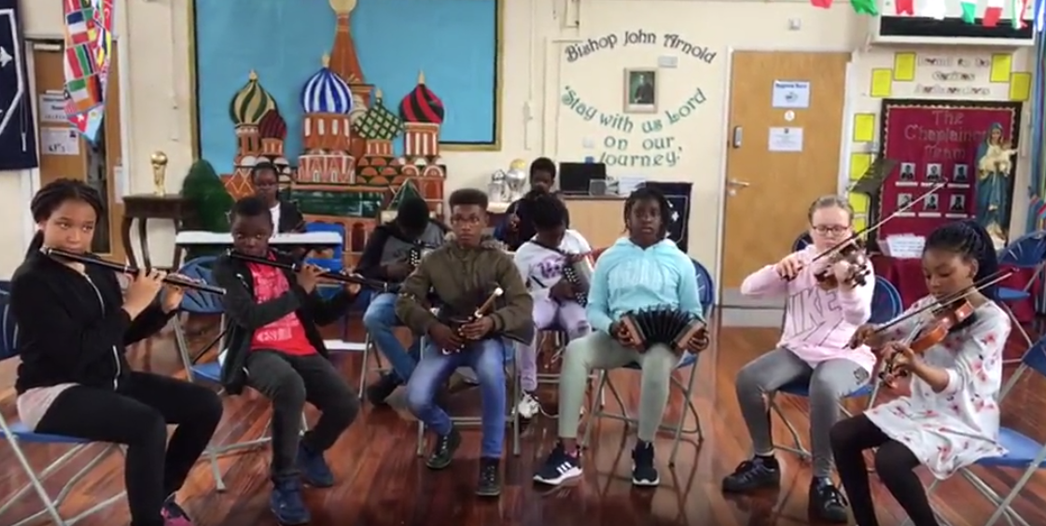
Each unit builds upon prior learning ensuring that there are opportunities for children to revisit previous learning, thus aiding children to know and remember more. Each year group will also revisit the key knowledge, skills and vocabulary from their previous year groups.
One KS2 class will also be allocated an additional Music lesson for whole class instrument tuition where they will be taught to play an instrument such as the guitar or ukulele.
EYFS
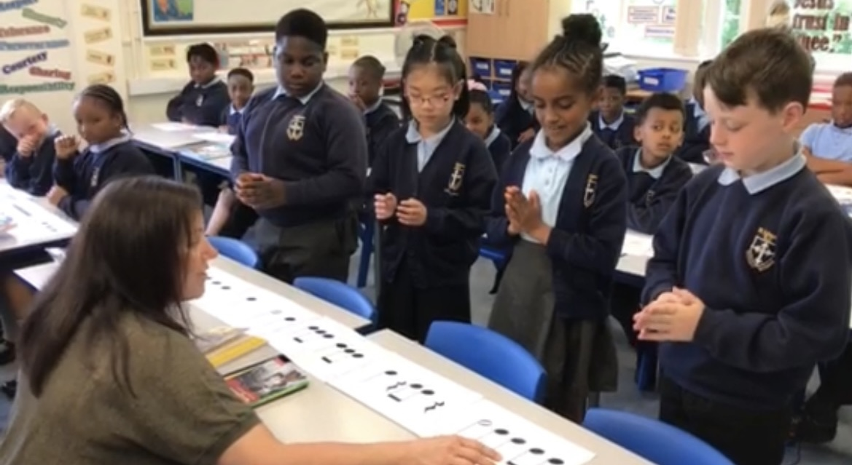
In the Early Years Foundation Stage, our curriculum is taken from the statutory framework. Within Expressive Arts and Design and Communication and Language, children are taught a wide repertoire of nursery rhymes which not only supports their language acquisition and builds on their vocabulary but also teaches them to recognise and enjoy music, remember lyrics and sing along in groups or on their own. Children are given the opportunity to listen attentively, move to and talk about music, expressing their feelings and responses, preparing them to create their own song, or improvise around a song they already know. We also provide lots of opportunities for children to play instruments with increasing control to express their feelings and ideas. Our Reception class has access to and uses Charanga to support them with their learning which helps to prepare children for their learning in KS1 as they will be familiar with the platform and the structure of a unit.
Our curriculum in the EYFS is planned to prepare children for KS1, where they will build upon prior learning. For example, in Year 1, children will learn to sing in unison, use instruments to perform simple rhythm and pitch patterns and improvise and compose with rhythm grids.

What does assessment look like in Music?
In each Music lesson, we are continually assessing our children to find out what they know and what they need to know next. We assess children in a variety of ways for example, by observing children singing and playing instruments or by questioning and discussing what they have been learning throughout the lesson and of course through their playing of instruments. We also provide opportunities for children to assess their own learning and that of their peers by allowing them to watch their performances back and reflect on their strengths and areas for development. At the end of each unit children will be given a mini quiz to assess their knowledge and understanding of key concepts within the unit.

How do we provide extra support and challenge to those who need it?
Within every lesson we provide children with the same chances and opportunities to learn ensuring an inclusive learning environment. However, through the continuous assessment within lessons, teachers are able to identify children who may need extra support or challenge. We have various different methods of supporting children and we select the best method for each individual child as we recognise that no two children are the same and what works best for them will be specific to their needs. We may support a child through; targeted support from a teacher or teaching assistant, visual aids such as writing the notes on the instrument or providing extra support through a music intervention group. We may also use modelling and scaffolding to break down the learning into smaller steps for example listening to the notes, clapping the notes, saying the notes before finally playing the notes.
Within the lesson, we may also identify a child who needs further challenge to deepen their learning and the bronze, silver and gold challenges on Charanga are great tools to aid this. Other methods of challenge may include asking the child to teach their partner and explain the different vocabulary used or even compose a tune of their own using given notes and rules. Children who are identified as gifted and talented may also be invited to attend an extra music session to develop their skills further.

Reading
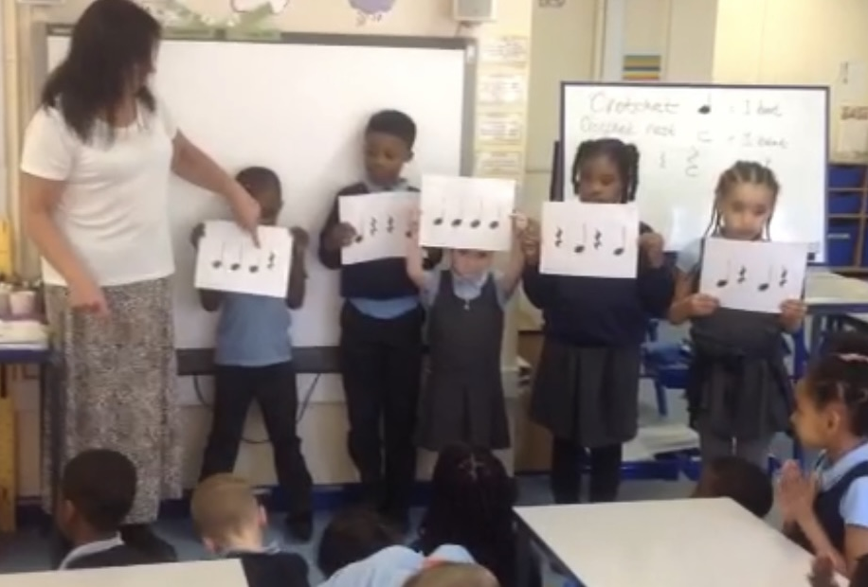
Children learn to read the notes they are going to play and eventually, they will learn to read these on a stave. Our children are also encouraged to read about musicians and composers of the past and present and the impact they have or have had on our society today. We have a large collection of books in our school and class libraries available for children who would like to find out more about different musicians, composers and genres of music

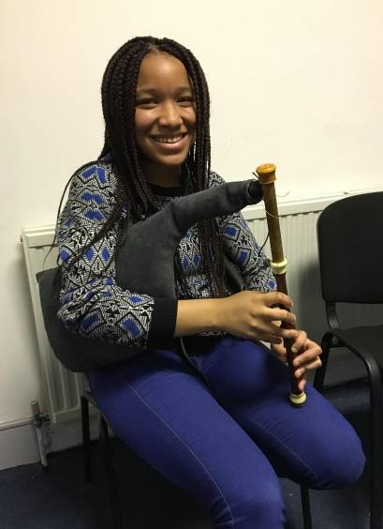
Safeguarding and well-being
A child’s welfare, well-being and safety is of the utmost importance to us. A child can’t learn or make any progress in school if they don’t feel safe and secure. We all know they need to be happy and we are here to ensure all of our children are nurtured to reach their full potential. Sometimes, learning in a lesson can trigger something to upset a child, perhaps a piece of music or song lyric can upset them. We have a special programme in school to help any children who may be struggling with their emotions and well-being. If you have any concerns about your child or in fact another child, please do not hesitate to contact one of our Designated Safeguarding Leads who will be happy to talk through any concerns you may have.

Personal Development
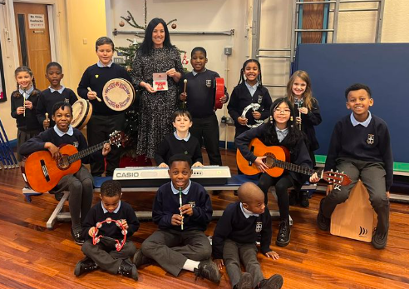
We know how listening to and playing music and singing has such a positive impact on children’s personal development and we will do our best to enrich the curriculum by providing educational visits to support their learning. By studying carefully selected musicians from the past and present we aim to help children make links between what they are learning in class and their own lives. Furthermore, we endeavor to enrich our children’s experiences with visits to observe musicians’ performances and to demonstrate how music enhances the performance of others. Pupils have the opportunity to visit the Halle St Peter’s, The Stoller Hall, Bridgewater Hall and other music venues within the local area such as Band on the Wall to apply their learning to real life experiences and learn more about their heritage through music. Our children were very proud to be involved in creating an anthem for the Women’s Euros 2022 with the Royal Philharmonic Orchestra, which they performed in the Manchester Fan Zone in July 2022.

How can I support my child’s learning in Music?
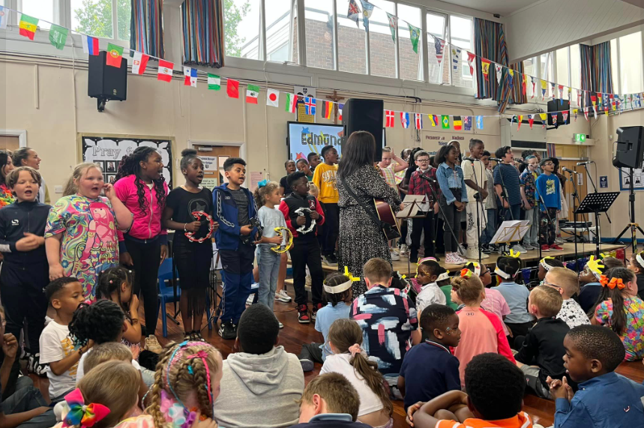
There are lots of things you can do! Firstly, talk to your child about what they are learning in their music lessons – what musicians are they learning about as well as what songs they are learning. Let them listen to and appreciate lots of different music. Talk to them about your favourite music, bands, artists and songs and how they have influenced you. We can foster a love of music together and we know how good it is for our mental health and well-being. We often have parents asking about musical instruments and these can make for fantastic Christmas or birthday presents; guitars, tin whistles and ukuleles are not expensive and your child will love playing tunes and songs they learn in school. If this is something you would like to discuss further, please call the school and ask to speak to Mrs Durcan so she can advise you. We would also encourage children to attend a local Music Centre where they can learn to play an instrument and be part of a band and the best part? They’re free!!

